**User Authentication module :**

Problem Statement:

Need to Build a User Authentication Module.

**Tools and Technologies Used**

* Spring Boot 2.3.1.RELEASE
* JDK 1.8
* Maven - 3.2+
* IDE - Eclipse or Spring Tool Suite (STS)
* MYSQL
* PostMan
* JAVA 8 Features
* Spring Security

## Creating and Importing a Project

There are many ways to create a Spring Boot application. The simplest way is to use Spring Initializr at <http://start.spring.io/>, which is an online Spring Boot application generator.

we have specified the following details:

* Generate: Maven Project
* Java Version: 1.8 (Default)
* Spring Boot:2.3.1 Release
* Package Name: com.km.authentication
* Packaging: jar (This is the default value)
* Dependencies: Web, JPA, MySQL, Security

## Project Structure

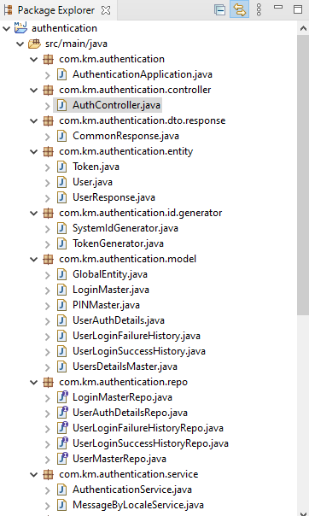

## Database Create SQL Scripts

**Table 1:**

Main Table: **authentication.users_details_master**

This table is used to store the all Users information like Username, encrypted pass word etc.

CREATE TABLE users_details_master (

system_id varchar(30) NOT NULL,

created_by varchar(255) DEFAULT NULL,

created_on datetime NOT NULL,

modified_by varchar(80) NOT NULL,

modified_on datetime NOT NULL,

incorrect_count int NOT NULL,

last_updated_date datetime DEFAULT NULL,

password varchar(150) NOT NULL,

previous_password varchar(150) NOT NULL,

status int NOT NULL,

user_name varchar(60) NOT NULL,

PRIMARY KEY (system_id)

) ENGINE=InnoDB DEFAULT CHARSET=utf8mb4 COLLATE=utf8mb4_0900_ai_ci;

Output:



Table 2 :

authentication.login_master

This table is used to maintain the login information (UserName info as Email/Phone No).Its join with the table authentication.users_details_master. Key issystem_id.

CREATE TABLE login_master (

login_id varchar(80) NOT NULL,

created_by varchar(255) DEFAULT NULL,

created_on datetime NOT NULL,

modified_by varchar(80) NOT NULL,

modified_on datetime NOT NULL,

system_id varchar(30) DEFAULT NULL,

PRIMARY KEY (login_id),

KEY `FKm1t62dds8sqodwd6u6kknxji1` (system_id),

CONSTRAINT `FKm1t62dds8sqodwd6u6kknxji1` FOREIGN KEY (`system_id`) REFERENCES `users_details_master` (`system_id`)

) ENGINE=InnoDB DEFAULT CHARSET=utf8mb4 COLLATE=utf8mb4_0900_ai_ci;

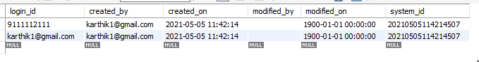

Note : We can able to use username as MobileNo/Email.

Table 3: authentication.user_login_failure_history.

**This is table is used to stored failure log information after failure authentication.**

CREATE TABLE **user_login_failure_history**(

id bigint NOT NULL,

login_date datetime NOT NULL,

system_id varchar(30) NOT NULL,

user_name varchar(60) NOT NULL,

PRIMARY KEY (`id`)

) ENGINE=InnoDB DEFAULT CHARSET=utf8mb4 COLLATE=utf8mb4_0900_ai_ci;

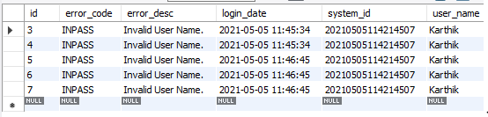

Table 4: **authentication.user_login_success_history.**

**This is table is used to stored successful log information after successful authentication.**

CREATE TABLE user_login_success_history(

id bigint NOT NULL,

login_date datetime NOT NULL,

system_id varchar(30) NOT NULL,

user_name varchar(60) NOT NULL,

PRIMARY KEY (`id`)

) ENGINE=InnoDB DEFAULT CHARSET=utf8mb4 COLLATE=utf8mb4_0900_ai_ci;

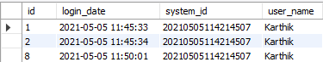

**Token Generation Details:**

**Generate UUID token:**

Class : TokenGenerator.class



**Validate Token exists:**

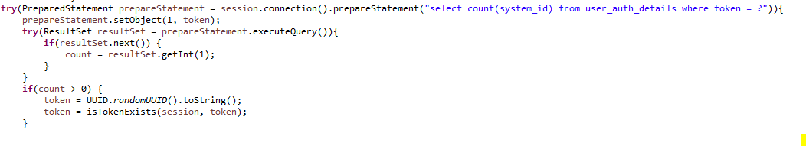

**System Id Generation:**

Class : SystemIdGenerator.class

Unique Id generation for Primary Key.

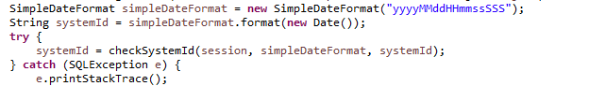

**Validate Id exists:**

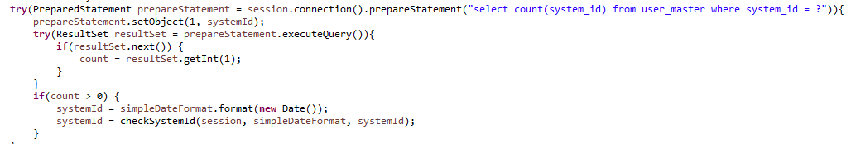

## Spring Rest Controller - AuthController.java

Class : AuthController.java

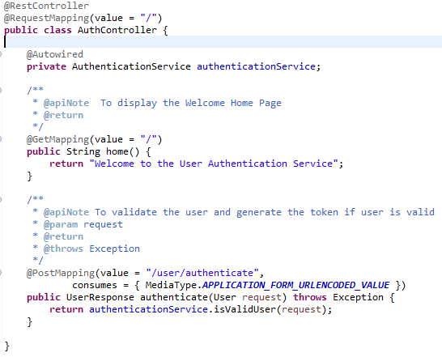

## Spring Rest Service - AuthenticationService.java

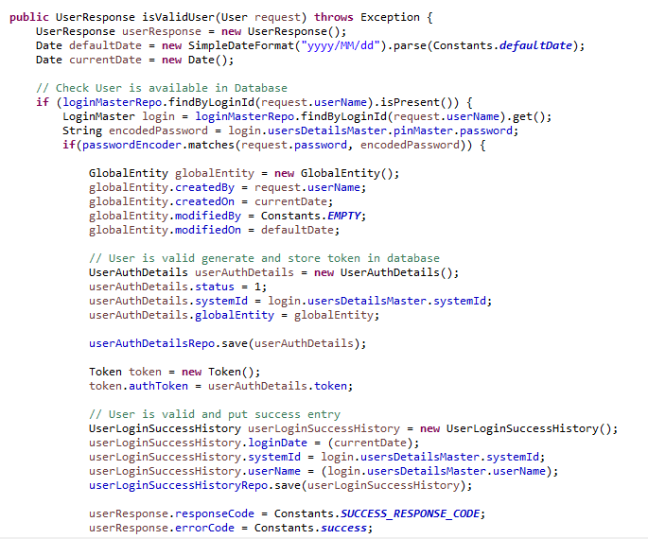

**Testing :**

Step 1 :

Need to do Maven build after import the Projects or run the class (UserMasterRepoTests.class) which has contains user details, Same details will be inserted into respective tables(users_details_master,login_master).

**Step 2: Execute the Tests.**

**Home Page**

**Test 1: Using Post Man**

Valid User Authentication

Invalid UserName

Invalid Password

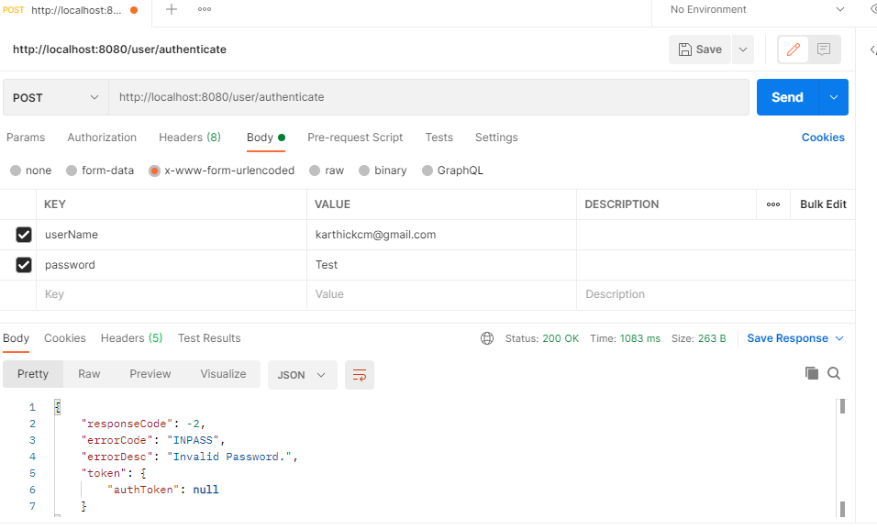

**Test 2: JUNIT Test Cases:**

**Class :** AuthenticationServiceTest.class

**Success:**

@Before

**public** **void** setUpData() {

request = **new** UserAuthRequestDto();

request.setUserName("karthickcm@gmail.com");

request.setPassword("Test@123");

}

@Test

**public** **void** verifyValidUser() **throws** Exception {

*assertEquals*(0, authentication.isValidUser(request).getResponseCode());

*assertEquals*("000", authentication.isValidUser(request).getErrorCode());

}

**INUSNM=Invalid User Name.**

@Before

**public** **void** setUpData() {

request = **new** UserAuthRequestDto();

request.setUserName("karthickcm@gmail.com");

request.setPassword("Test@123");

}

@Test

**public** **void** verifyInvalidUser() **throws** Exception {

request.setUserName("Test");

*assertEquals*(-2, authentication.isValidUser(request).getResponseCode());

*assertEquals*("INUSER", authentication.isValidUser(request).getErrorCode());

}

**INPASS=Invalid Password.**

@Before

**public** **void** setUpData() {

request = **new** UserAuthRequestDto();

request.setUserName("karthickcm@gmail.com");

request.setPassword("Test@123");

}

@Test

**public** **void** verifyInvalidPassword() **throws** Exception {

request.setPassword("test");

*assertEquals*(-2, authentication.isValidUser(request).getResponseCode());

*assertEquals*("INPASS", authentication.isValidUser(request).getErrorCode());

}